**Task -8**

**Output**

1. Write a Java Program that declares four integer variables a, b, c and d. Then write and if statement that checks sum of a and b is greater than sum of c and d. If the condition is true, the program should output a message indicating the sum of a and b is greater the sum of c and d.

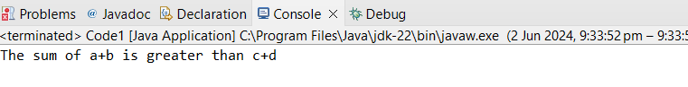

1. Have a variable store an integer. Create an if statement to find out if it’s an even number. 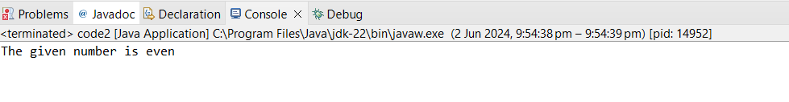
2. Write a program to print the characters from A to Z.

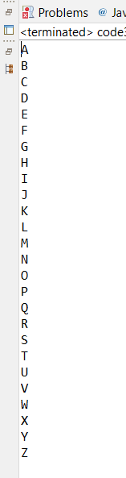

1. Write a Java program to get 2 numbers from the user and swap their values without any loss of data. You can make use of additional variable for swapping. Print the corresponding swaped values of two numbers and output in the console.

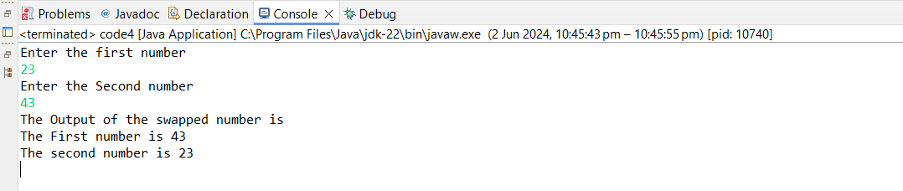

1. Write a program to check its prime number or not.

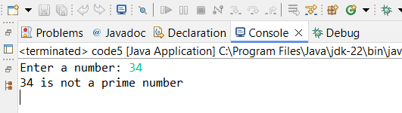

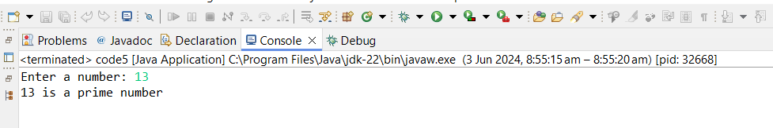

1. Write a program to print factorial of a given number

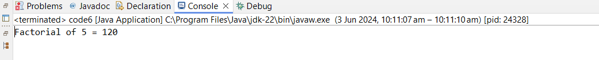

1. Write a program to print the length of the given string.

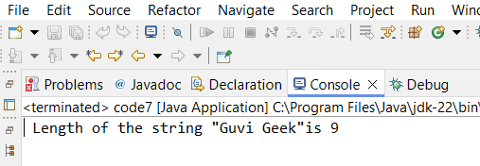

1. Write a program to print “guvi” 10 times.

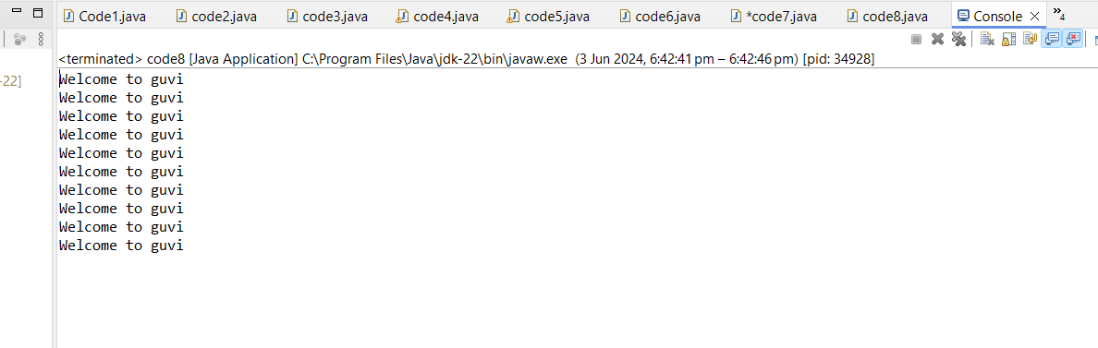

1. Write a program to check wheather the person is senior citizen or not.

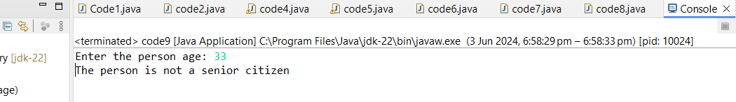

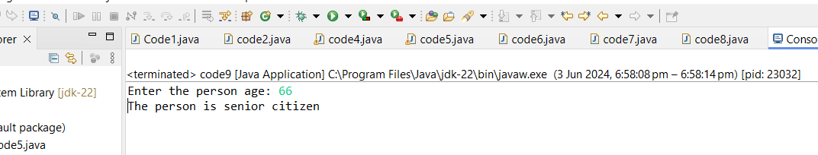

1. Write a program to Count Number of digits in an Integer.

